Kingsway Christian College
Maths Department
Course: Math Methods unit 3
Assessment Task: Test 2
Student Name: ________________________________________________________
Date: 23rd & 24th March 2017
Assessment Score: ____________ / 50
Year Score: __________________
Comments: ________________________________________________________
___________________________________________________________________________
___________________________________________________________________________
___________________________________________________________________________
___________________________________________________________________________
___________________________________________________________________________
___________________________________________________________________________
___________________________________________________________________________
___________________________________________________________________________

Teacher signature: ________________________________________________________

Parent/ Guardian signature: _____________________________________________
Comments: ________________________________________________________
___________________________________________________________________________
___________________________________________________________________________
___________________________________________________________________________
___________________________________________________________________________
___________________________________________________________________________

Math Methods Unit 3 Test 2 2017
Differentiation
Resource Free Time: 30 minutes Marks: / 27
Only a formula sheet is allowed for this section. No calculator or notes allowed.

Question 1 (6 marks)
(a) For what values of c does the polynomial 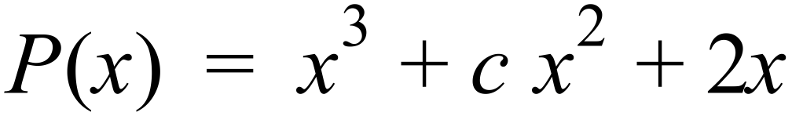 have an inflection point where x = 3? (3 marks)

(b) Sketch the graph of a function that such that: (3 marks)
- 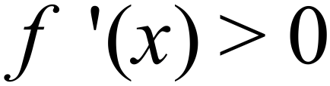 for all $x, x$ $≠1 and x≠3$
- vertical asymptote at x = 1
- $f\left(x\right)>0$if $x<1 or x>3$
- $f\left(x\right)<0$if $1<x<3$
- $f^{''}\left(3\right)=0$ and $f^{'}\left(3\right)=0$

Question 2 (6 marks)
Determine the maximum and minimum value for f (x) and the value of x at which they occur, for the function 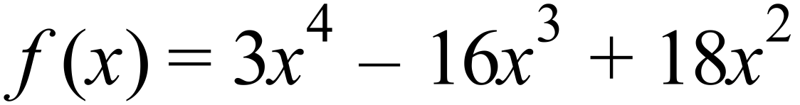 over the domain 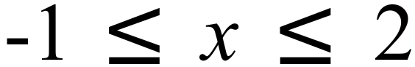 .

Question 3 (7 marks)
Determine the coordinates of all intercepts, stationary points and points of inflection of the function 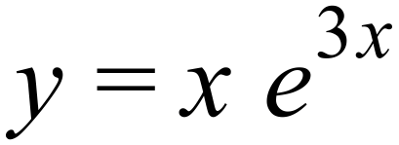.
Justify the nature of the stationary points found using a standard test.

Question 4 (3 marks)
Determine the equation of the normal to the curve $y=x(3-x)²$ at (2,2).

Question 5 (5 marks)
Find the equation of the tangent to the curve $y=2x+cos2x$ at the point ($\frac{π}{3}$ ; $\frac{2π}{3}-\frac{1}{2})$

Math Methods Unit 3 Test 2 2017 Differentiation
Name__________________________
Resource Assumed Time: 25 minutes Marks: / 23
CAS calculator and a formula sheet are allowed for this section

Question 6 (5 marks)
A cylindrical can is to be made to hold 1 000 cm³ of oil. Find the dimensions that will minimise the amount of the metal to make the can. Assume the can is made with a lid.

Question 7 (9 marks)
The cost in dollars of producing $x$ items is given by: $C\left(x\right)=\left(3000+5x\right).$
The revenue per item sold is given by $$(40-0.02x)$.
- State the revenue function $R(x)$ for $x$ number of items sold. (1 mark)

- Give an expression for the profit function $P(x)$. (1 mark)

- Determine how many items are needed to make a maximum profit and state the
maximum profit. (3 marks)

- Explain clearly if a loss occurred and when it occurred. (2 marks)

- Determine the marginal profit of the 250th item sold. (2 marks)

Question 8 (4 marks)
Use derivatives to find the approximate change in the radius of a spherical balloon corresponding to a change in its volume from 200 cm³ to 195 cm³. Answer to 4 decimal places.

Question 9 (5 marks)
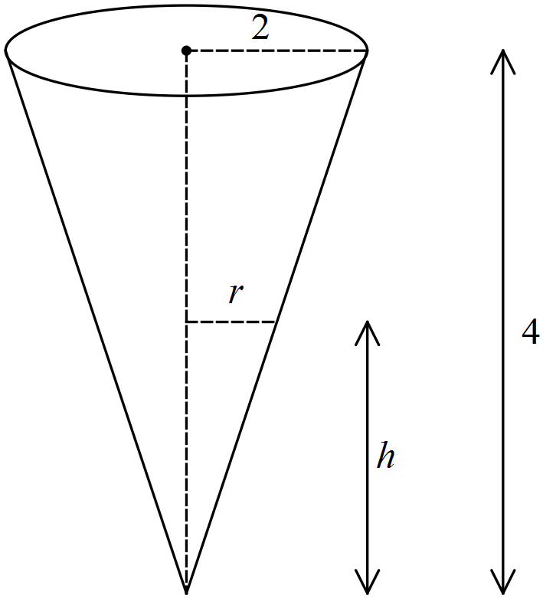A water tank has the shape of an inverted circular cone with base radius 2 m and height 4 m.

- Proof that the volume of the tank is given by the following formula:
$V\left(h\right)= \frac{1}{12}πh^{3}$ (1 mark)

- If water is being pumped into the tank at a rate of 2 m³/min, find the rate at which the
water level is rising when the water is 3 m deep.
Answer to the nearest cm/min. (4 marks)

